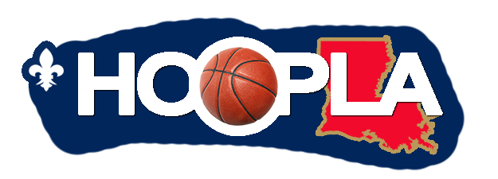
LEGISLATOR’S CHARITY FUND
HoopLA Event

NONPROFIT APPLICATION
The mission of the nonprofit must be for the benefit and enrichment of the youth in your community.
Due Thursday, May 18th 2017
Nonprofit: ________________________________________________________________

Executive Director: ____________________________ Contact Person: _________________________

Address: ____________________________________________________________________________

Telephone: _______________________________________ Facsimile: _______________________

Contact Email: ____________________________________ EIN: ____________________________

Nonprofit Organization’s Mission Statement (no more than 50 words):

List type of services provided by your nonprofit organization:

What needs are you addressing?

Please email completed application to Carla Mouton cmouton@northshorefoundation.org
care of the Legislator’s Charity Fund at the Northshore Community Foundation
