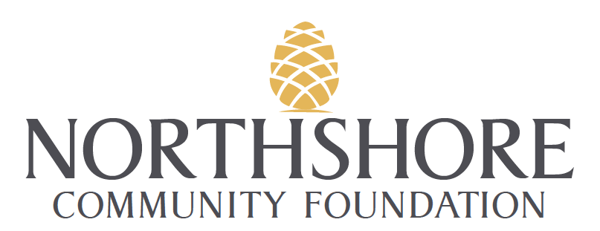

Gene and Betty Van Norman Scholarship Fund

PURPOSE

Through the generosity of Betty Van Norman, the Northshore Community Foundation is able to award scholarships to students enrolled in an Engineering discipline who are attending Louisiana State University (LSU).

The Gene Betty Van Norman Scholarship Fund was created in 2016 in collaboration with the Northshore Community Foundation to offer college scholarships to students attending LSU who are enrolled in an Engineering discipline. The scholarship is overseen by the Northshore Community Foundation in order to take advantage of the area foundation's management expertise. This fund is to provide a yearly $12,500 scholarship award to 2nd year students enrolled in an Engineering discipline.

Scholarship to be used toward the following, in order of priority: tuition and fees; books and supplies. The recipients are to be selected by an independent Scholarship Advisory Committee that is appointed by the Foundation.

CRITERIA
In making its decision, the Scholarship Advisory Committee will use the following criteria:

- Minimum GPA of 3.0
- Candidate must be enrolled in an Engineering discipline
- Preference shall be given to students with financial need
- Scholarships shall be available to 2nd year students upon the recommendation of the Dean of the College of Engineering.

GUIDELINES
Each applicant must submit application to the Scholarship Advisory Committee by August 24th to include the following:

- The completed application form (APPLICATION DEADLINE: Friday August 24, 2018);
- One or more letters of recommendation from a counselor or college professor and mailed directly to the advisory committee;
- An official academic transcript including standardized test scores (minimum GPA is 3.0).

The scholarship will be awarded one-time annually valued at $12,500. The recipient must continue to demonstrate good character. At the end of each school year, the recipient will provide the Foundation with a narrative of the previous semester's' activities, an official transcript and class schedule for coming fall. A subsequent scholarship the check will be issued only upon receipt of these materials.

Should a recipient fail to meet the criteria in a given school year, the scholarship will be terminated. If the recipient has a serious reason, he or she may make a written appeal to the committee for reconsideration.

CONTACT
Please mail or email completed applications for this scholarship to:

Gene and Betty Van Norman Scholarship Fund Advisory Committee
c/o Northshore Community Foundation
807 North Columbia Street
Covington, LA 70433
Carla Mouton: cmouton@northshorefoundation.org

Gene and Betty Van Norman Scholarship Application

APPLICATION DEADLINE: Friday, August 24, 2018

PERSONAL INFORMATION
Name:
Local Address:

City: State: Zip:

Telephone:

Email:

Birth Date:

Circle one: Male Female

List the scholastic and honorary awards that you have received during your school career. Also, include any extracurricular activities in which you participated that you consider important. (Attach an additional sheet if necessary.)

List Noteworthy Achievements:

List any additional scholarships to be received:

Cumulative GPA:

If working, employer, and nature of employment:
Circle one: Full-Time Part-Time

FAMILY INFORMATION
Father's Name:
Address:

City: State: Zip:

His employer and nature of employment:

Mother's Name:

Address:

City: State: Zip:

Her employer and nature of employment:

Please give the following information on all children in the family (including yourself).
Name:
Age:
Name:
Age:
Name:
Age:

STATEMENT
Please provide a brief statement summarizing why you think you should be awarded a scholarship. You may use an additional sheet if necessary.

CERTIFICATION
We hereby certify that the information given in this application and in all attachments thereto is true, correct and complete to the best of our knowledge. We authorize the Gene and Betty Van Norman Scholarship Fund Advisory Committee to verify any and all facts provided in this application.

Applicant's Signature: Date:

IMPORTANT
Please check these items are included with your completed application:
- Counselor, and or college professor(s) letters of recommendation mailed or emailed directly to the Committee;
- An official student transcript including standardized test scores and the student's cumulative GPA at the end of the most recent school year.

Please mail or email completed application on or before August 24, 2018:
Northshore Community Foundation
Gene and Betty Van Norman Scholarship Fund
807 North Columbia Street
Covington, LA 70433
Carla Mouton: cmouton@northshorefoundation.org

